Selenium Hybrid Framework

(Python, Selenium, PyTest, Page Object Model, HTML Reports)

Step1: Create new project & Install all required packages/plugings

* pytest- Python built-in unit test framework
* Selenium- Selenium libraries
* webdriver-manager -- for drivers
* pytest-html – reports
* pytest-xdist –parallel testing
* openpyxl –xl files
* allure-pytest –report

Create requirements.txt file contains all packages and install it.

Step2: Create folder structure

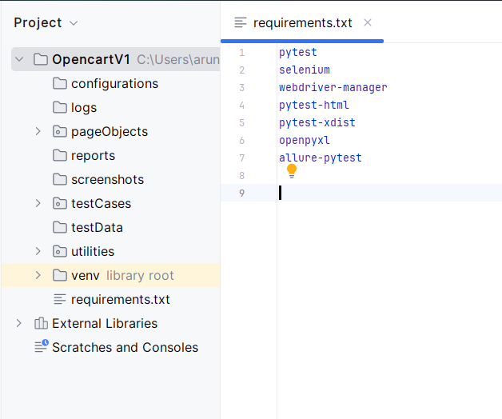

Step 3: Automating Register account test case

3.1: Create page object classes for HomePage & AccountRegistrationPage under pageObjects python package.

3.2: Create conftest.py under “testCases” with driver manager.

3.3 Create AccountRegistrationPage testcase under “testCases”

3.4 Write a utility file to generate random string from email.

Step 4: Capture screenshots on failures

4.1 Update AccountRegistrationPage testcase with capture screenshot under “testCases”

Step 5: Read common values from ini file

5.1: Add “config.ini” file in “configurations” folder

5.2: create “readProperties.py” utility file under utilities package to read common data.

5.3: Replace hard coded values in AccountRegistrationPage testCase